🔒 IT Support Standard Operating Procedure (SOP)

Document Title: Tier 1 Active Directory Account Management: Lockout Resolution
Attribute | Detail
Document ID | AD-SOP-2025-001
Version | 1.1 (Updated: Prerequisites & Escalation)
Owner | Mehadi Hasan / IT Department
Creation Date | 2025-12-16
Applicable Role | Tier 1 Help Desk Technician

I. Document Revision History
Version | Date | Description of Changes | Author
1.0 | 2025-12-16 | Initial Draft: Basic Unlock and Reset Procedure. | Mehadi Hasan
1.1 | 2025-12-16 | Added Prerequisites, Security Notes, Escalation, and Ticket Closure. | Mehadi Hasan

II. Prerequisites and Security Notes

A. Required Access and Tools
Before beginning the procedure, the technician must ensure they have the following:
- Tool: Active Directory Users and Computers (ADUC) console access.
- Permissions: Administrator or delegated permissions to manage user accounts (Reset Password, Unlock Account) within the relevant Organizational Units (OUs).
- Authentication: The user must be successfully identified via two security questions or an appropriate authentication method per policy.

B. Security and Compliance Mandates
Requirement | Description
Password Visibility | Technicians must NEVER know the user's permanent password. Use the "User must change password at next logon" option during any reset.
User Authentication | All changes (especially password resets) must follow strict authentication protocols to prevent unauthorized access.
Logging | Every action (unlock, reset, escalation) must be immediately logged in the ticket system with the time and resolution provided.

III. 📞 Account Management Procedure

A. Initial Call Protocol
The goal is to confirm the scope of the access issue and acquire the user's logon identifier.
Step | Action | Technician Script/Key Inquiry | Rationale
3.1 | Acknowledge & Identify | "Thank you for calling the Service Desk, I can help you. Please tell me what you are trying to access." | Professional start; establishes control.
3.2 | Scope Assessment | "Are you having trouble logging into multiple systems (like email, network drives, or VPN), or just one application?" | Confirms if it is a domain credential issue (AD) vs. an application issue.
3.3 | Data Collection | "Please provide your network Login ID (username) so I can locate your account." | Prepares for Active Directory look-up.
3.4 | Inform User | "I'll check your account status. It sounds like the system locked your account after too many incorrect password attempts, which is a standard security measure." | Sets expectation and educates the user.

B. Active Directory (ADUC) Look-up
Access the user account using the most efficient search method.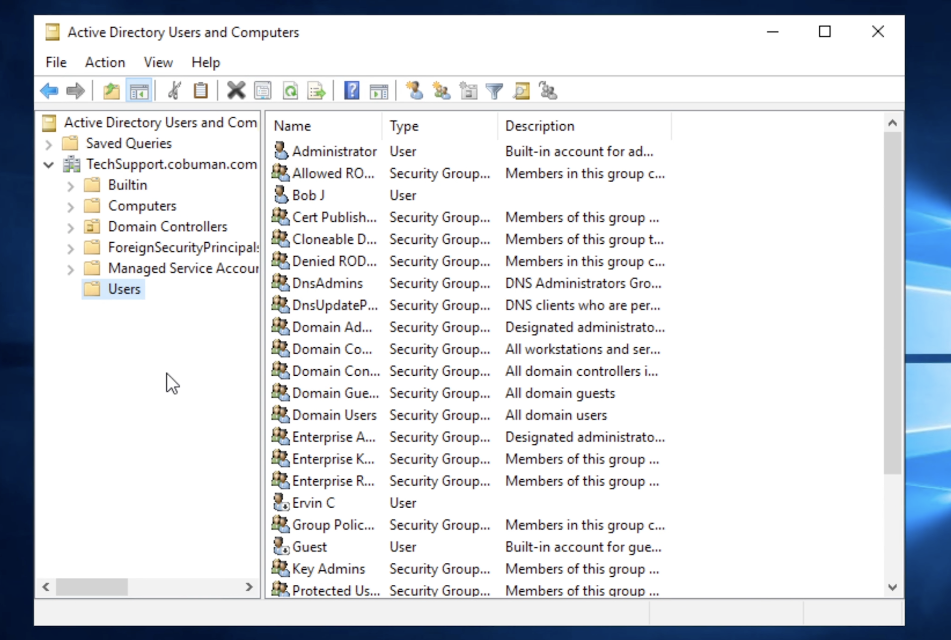
- Open: Launch the Active Directory Users and Computers (ADUC) management console.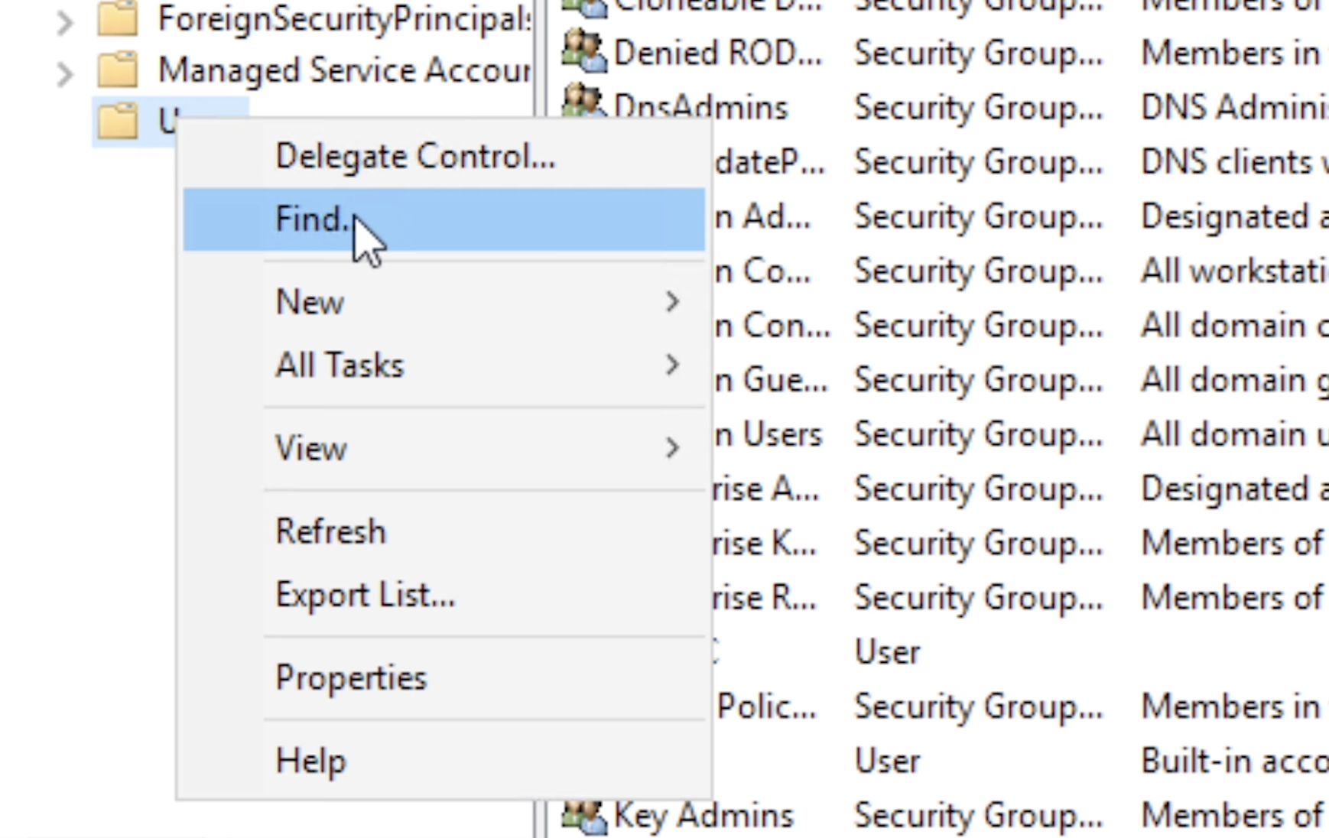
- Locate: Do NOT scroll through OUs. Instead, Right-click on the domain name or the designated Users OU.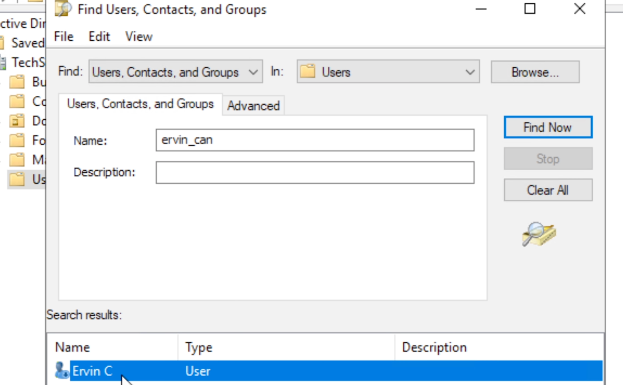
- Search: Select the Find... option. Input the user's Login ID and execute the search (Find Now).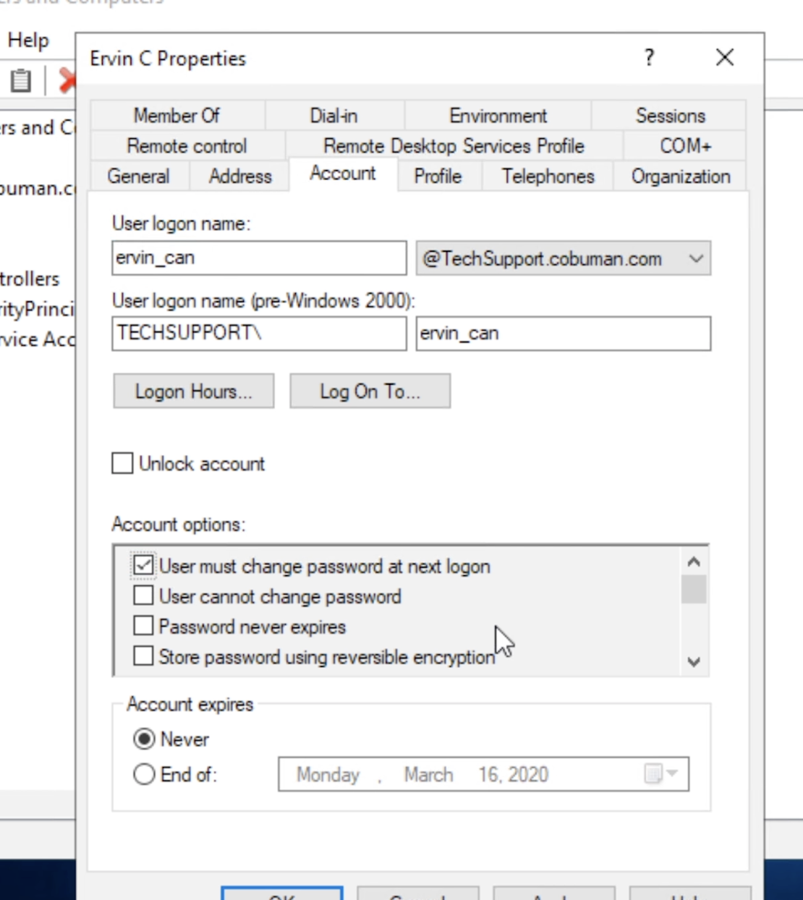
- Access: Double-click the returned user object to open the Properties dialog box.

IV. 🛠️ Resolution Pathways

Pathway 1: Unlocking the Locked Account (Primary Fix)
This is the fastest resolution if the user is confident they remember their password.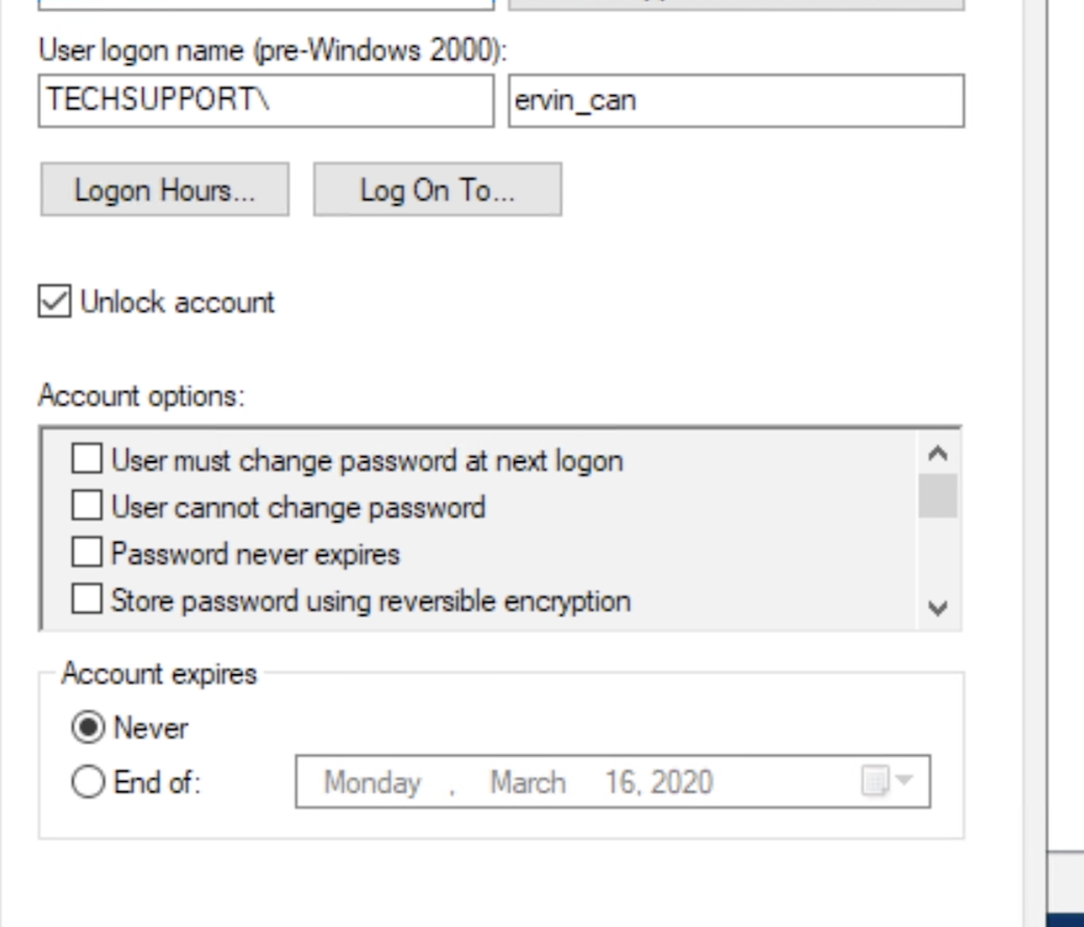
Step | ADUC Action | Required Field Input/Selection | Confirmation
4.1 | Navigate | Click the Account tab within the Properties dialog. | Verifies status of the account.
4.2 | Unlock | Under "Account options," ensure the box for "Unlock account" is CHECKED. | Clears the lockout flag from the Domain Controller.
4.3 | Commit | Click Apply, then OK. | Saves the unlocked status.
4.4 | Test | Instruct the user to immediately try logging in with their current password. | Confirms successful resolution.

Pathway 2: Password Reset (If Unlock Fails or is Requested)
This process is initiated if the user has forgotten their password or the unlock did not resolve the issue.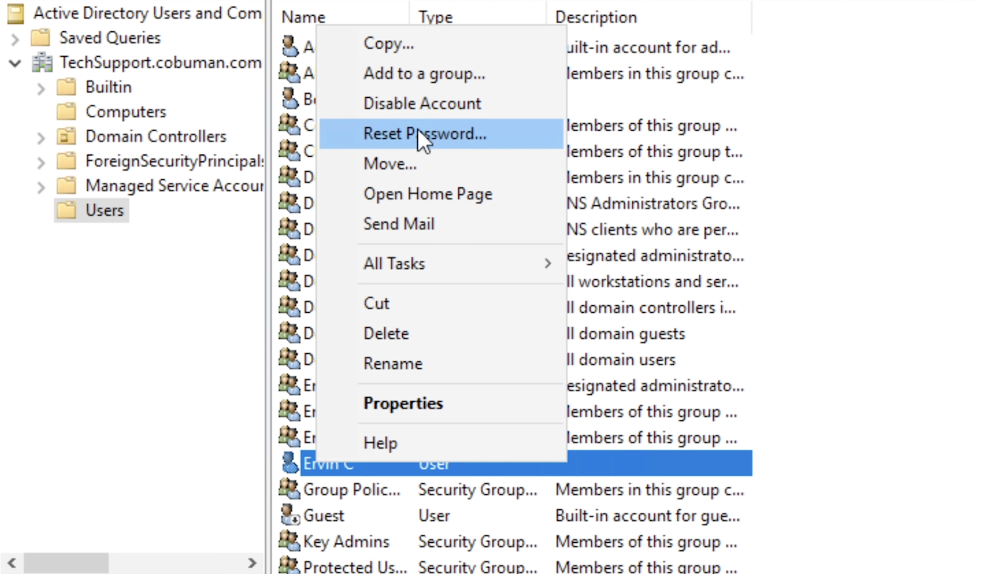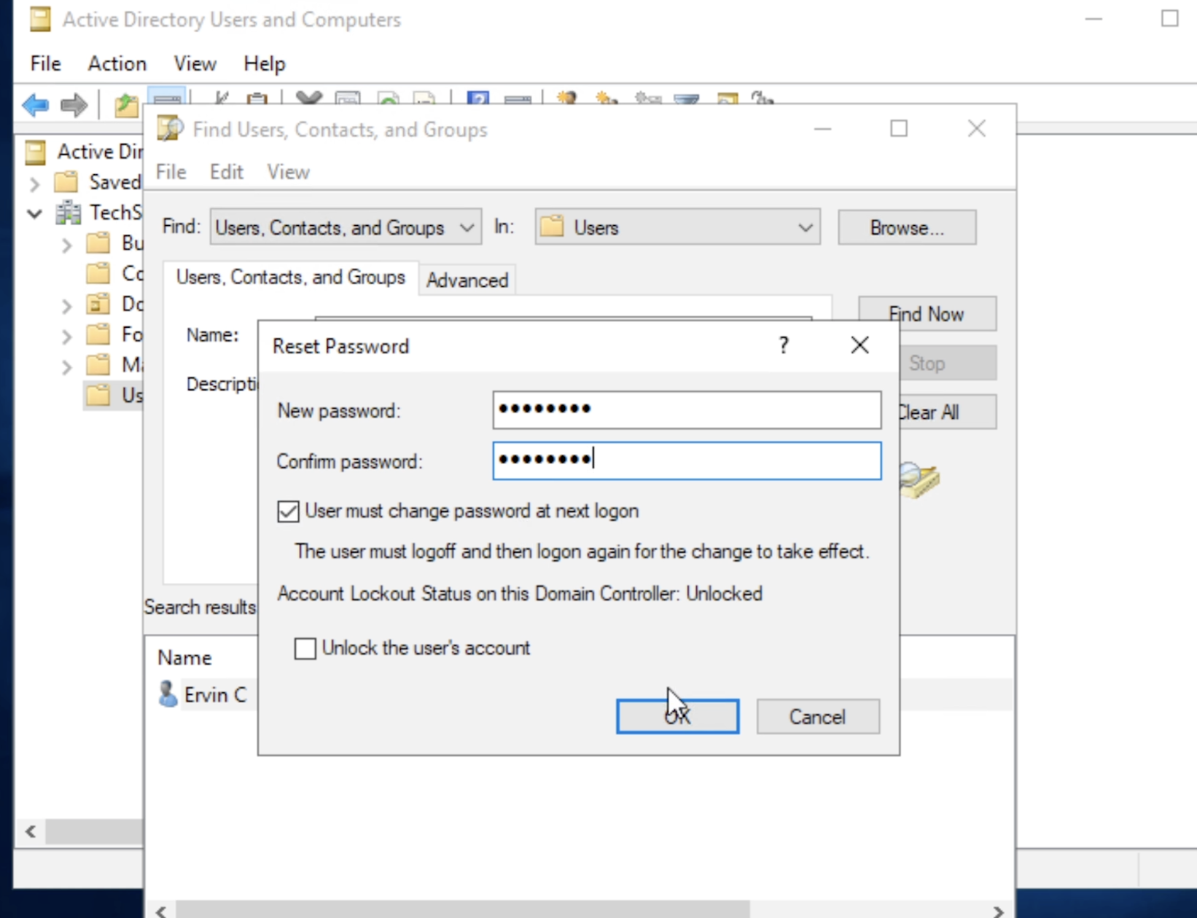
Step | ADUC Action | Required Field Input/Selection | Security Mandate
4.5 | Initiate | Right-click the user object and select Reset Password... | Opens the reset dialogue.
4.6 | Temporary Password | Enter a secure, temporary password (as per IT policy) in both the New password and Confirm password fields. | Provides the user with immediate access.
4.7 | Security Check | MANDATORY: Check the box "User must change password at next logon." | Enforces principle of least privilege.
4.8 | Commit & Close | Click OK. Provide the user with the temporary password and instruct them to change it immediately after logging in. | Completes the password change.

V. 📈 Error Handling and Escalation
If the issue persists after performing both Pathway 1 and Pathway 2, or if you encounter the following errors:
Issue/Error Encountered | Action Required | Escalation Tier
"Access Denied" when attempting to unlock/reset. | Verify delegated permissions. If permissions are correct, proceed to escalation. | Tier 2
Account Locks Immediately after being unlocked. | A device (e.g., mobile phone, shared workstation) is still submitting bad credentials. This requires a tool like LockoutStatus.exe to find the originating machine. | Tier 2
User Cannot Set New Password after reset. | Check the password policy complexity and ensure the user is not reusing a previous password. If error persists, escalate. | Tier 2
Account is Disabled (not just locked). | Do NOT re-enable. Immediately escalate the ticket to Tier 2 for verification of termination status or other HR/security holds. | Tier 2

VI. 🎫 Ticket Closure Protocol
Step | Action | Description
6.1 | Final Confirmation | Confirm with the user that they can access all required network resources.
6.2 | Documentation | Record the exact steps taken (Unlocked or Password Reset) in the ticket notes. Include the time of resolution.
6.3 | Resolution Code | Assign the ticket the appropriate resolution code (e.g., Resolved - Account Management, Resolved - Password Reset).
6.4 | Closing Remarks | "I'm glad that worked out for you. Is there anything else I can help you with today?" Conclude the call professionally.

